

**Hyperion Planning Drill Though End User Manual**

**Project Name:** **P28 North American Regional Financial Planning, Phase 1, Release 1B**

**Prepared By**

|  |  |
| --- | --- |
| **Document Owner(s)** | **Role** |
| Ray Lin | Analyst |

**Version Control**

| **Version** | **Date** | **Author** | **Change Description** |
| --- | --- | --- | --- |
| 1.0 | 12/02/2014 | Ray Lin | Initial draft |
| 1.1 | 12/08/2014 | Ray Lin | Added additional screenshots |

# Table of Contents

1. Table of Contents 2

1. Hyperion Planning Drill Through 3

1.1. Overview 3

2. Drilling in Web Forms 3

2.1. Drillable regions 3

2.2. Drilling in the Web (Method 1) 4

2.3. Drilling in the Web (Method 2) 6

3. Drilling in SmartView, Hyperion Planning Connection 8

3.1. Drillable Regions 8

3.2. Drilling in SmartView (Method 1) 9

3.3. Drilling in SmartView (Method 2) 11

4. Drilling in SmartView, Essbase Connection 14

4.1. Drillable regions 14

4.2. Drilling in SmartView, Essbase Connection (Method 1) 14

4.3. Drilling in SmartView, Essbase Connection (Method 2) 16

5. Drilling in Reports 18

5.1. Overview 18

5.2. Opening Reports in Query Ready mode from SmartView 19

5.3. Opening Reports in Query Ready Mode from the Web 21

6. Other Settings 25

6.1. SmartView Drill Through ToolTip Settings 25

# Hyperion Planning Drill Through

## Overview

This document describes the capability to drill through to more detail on actuals from within the Hyperion budgeting and planning system. The Hyperion system already provides drilldown, but does not provide drill through. Drilldown lets users look at data at different levels (ex. cost center up to Company), but these are just different aggregations of the lowest (ie. level 0) data. Drill through would allow users to go one step further to see the underlying transactions that made up the lowest level 0 number (ie. the actuals ledger total for an account and cost center for a month). For example, drill through would show journal entries, accounts payable, expenses detail or other transactions.  
  
Drillable cells in Hyperion planning are accessible only in the PL cube at specific intersections. The drilling functionality can be accessed in both the web form and SmartView. Reports do not natively support drill through but drilling can be achieved by opening the report in ad-hoc mode.

# Drilling in Web Forms

## Drillable regions

Drillable regions in the Hyperion Planning web forms are indicated by a green triangle in the upper right corner of a cell as illustrated in the screenshot below.

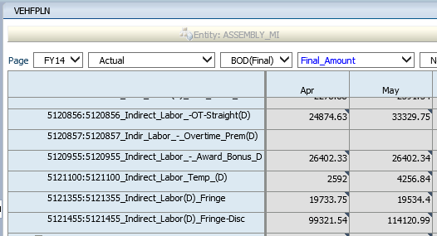

In the current implementation of drill through, only the PL cube will have drill through enabled. Additionally, drill through is only possible at specific intersections and forms. See the table below for the intersection requirements.

|  |  |
| --- | --- |
| Dimension | Measure |
| **Scenario** | Actual |
| **Version** | BOD(Final) |
| **Measure** | Final_Amount |
| **Product** | No_Product or Total_Products |

See the tables below for the forms that will be enabled for drill through.



## Drilling in the Web (Method 1)

1. Click the cell once to highlight the cell.

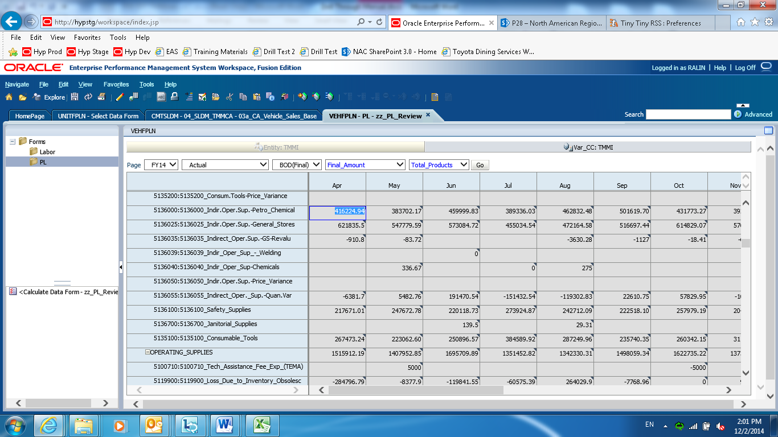

1. Click the cell again to bring up the drill through button

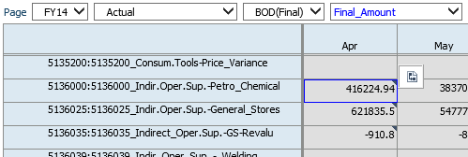

1. Click the drill through button to select drill through method (Drill to IE or Drill to Excel)

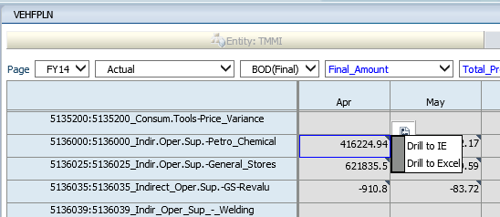

1. Click *Drill to IE* to execute the drill and view the data in a web page

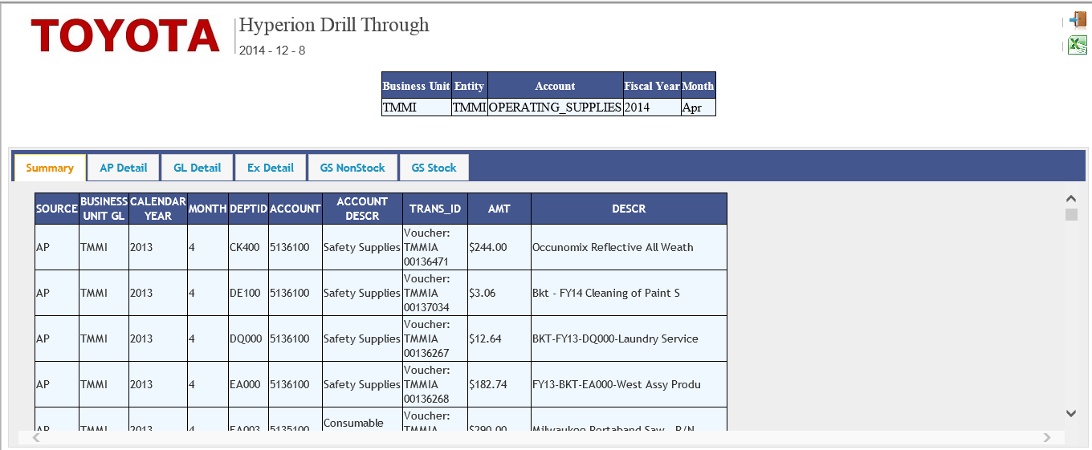

1. Click *Drill to Excel* to execute the drill and view the data directly in Excel

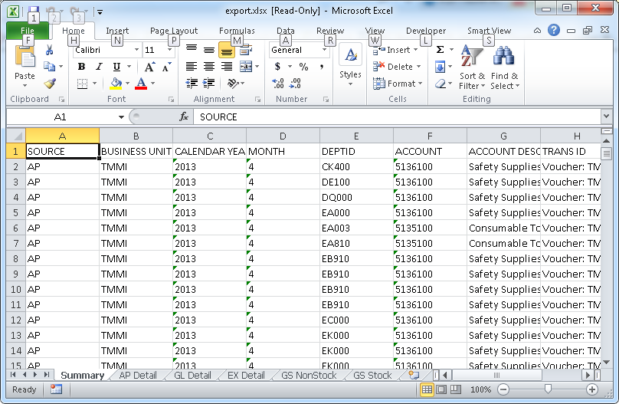

## Drilling in the Web (Method 2)

1. Click the cell once to highlight the cell.



1. In the toolbar, select *Edit* -> *Drill Through* to bring up the drill through methods

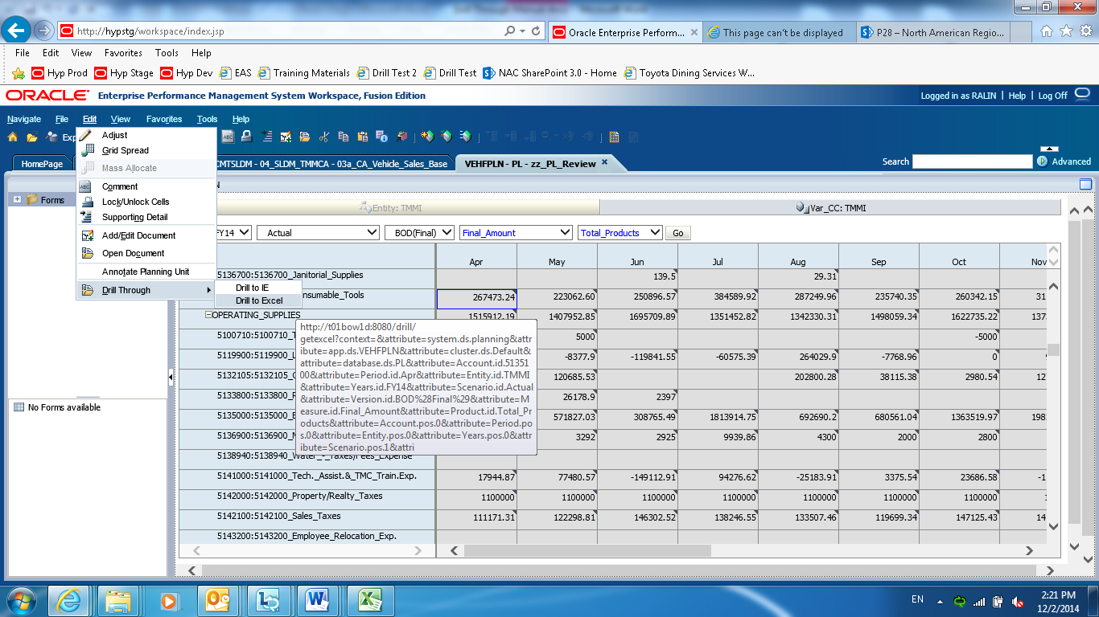

1. Click *Drill to IE* to execute the drill and view the data in a web page



1. Click *Drill to Excel* to execute the drill and view the data directly in Excel



# Drilling in SmartView, Hyperion Planning Connection

Drilling in SmartView is supported using both the Hyperion Planning connection and the Essbase connection though forms and ad-hoc reports. This section will describe drilling through the Hyperion Planning connection.



## Drillable Regions

Drillable regions in the Hyperion Planning web forms or ad-hoc grids are indicated by a green outline around the border of a cell. See the screenshot below for details.

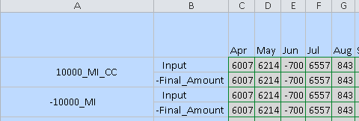

In the current implementation of drill through, only the PL cube will have drill through enabled. Additionally, drill through is only possible at specific intersections and forms. See the table below for the intersection requirements.

|  |  |
| --- | --- |
| Dimension | Measure |
| **Scenario** | Actual |
| **Version** | BOD(Final) |
| **Measure** | Final_Amount |
| **Product** | No_Product or Total_Products |

See the tables below for the forms that will be enabled for drill through.



Note that it is currently not possible to execute a drill through on forms that require a user variable, such as form zz_PL_Review. Trying to drill through on one of these forms will result in the following error.

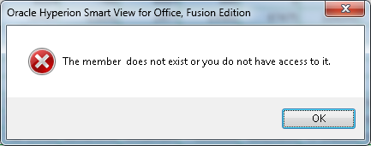

To drill through on data that are on forms that have user variables, either open the form as an ad-hoc grid or select another version of the form that does not use a user variable.

## Drilling in SmartView (Method 1)

1. Click to select a drillable cell

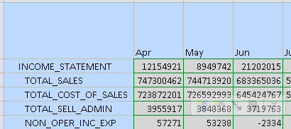

1. Hover over the ToolTip menu to find the drill through button

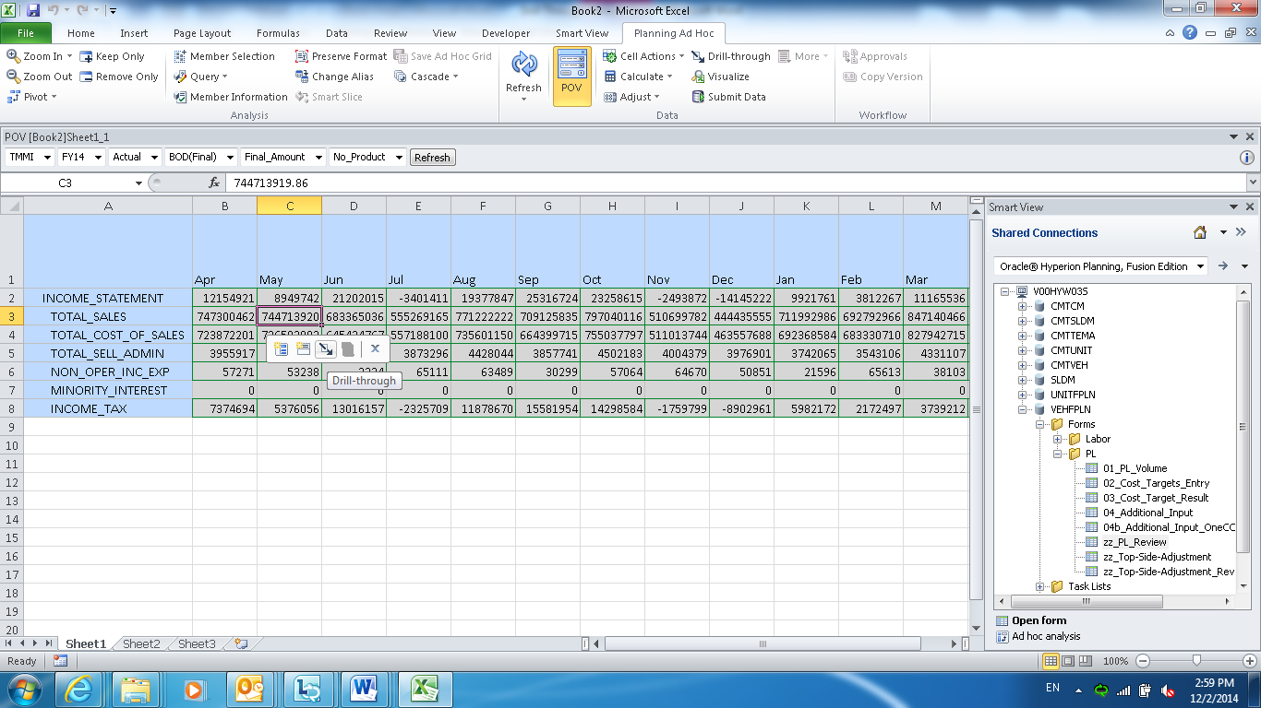

1. Clicking the drill through button opens the menu to select the drill through method

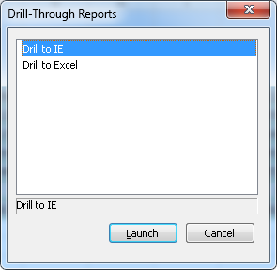

1. Click *Drill to IE* to execute the drill and view the data in a web page



1. Click *Drill to Excel* to execute the drill and view the data directly in Excel



## Drilling in SmartView (Method 2)

1. Click to select a drillable cell



1. In the Planning tab in the Excel ribbon, click on the *Drill-through* button

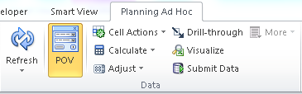

1. Clicking the *Drill-through* button opens the menu to select the drill through method



1. Click *Drill to IE* to execute the drill and view the data in a web page



1. Click *Drill to Excel* to execute the drill and view the data directly in Excel



# Drilling in SmartView, Essbase Connection



## Drillable regions

The drillable regions in an Essbase connection are the same as in the Hyperion Planning connection or in the web but cells do not have special indicators like drillable cells using the previous two methods.

Like through the Hyperion Planning connection, only the PL cube will have drill through enabled. Additionally, drill through is only possible at specific intersections and forms. See the table below for the intersection requirements.

|  |  |
| --- | --- |
| Dimension | Measure |
| **Scenario** | Actual |
| **Version** | BOD(Final) |
| **Measure** | Final_Amount |
| **Product** | No_Product or Total_Products |

See the tables below for the forms that will be enabled for drill through.



## Drilling in SmartView, Essbase Connection (Method 1)

1. Double click on a cell to bring up the menu to select the drill through method

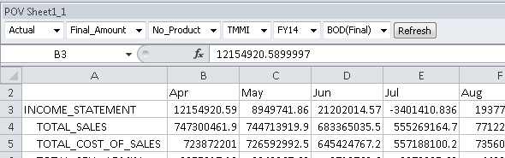

**NOTE**: If double clicking does not open the drill through menu, it is likely that the cell is not drillable.



1. Click *Drill to IE* to execute the drill and view the data in a web page



1. Click *Drill to Excel* to execute the drill and view the data directly in Excel



## Drilling in SmartView, Essbase Connection (Method 2)

1. Click to select a drillable cell

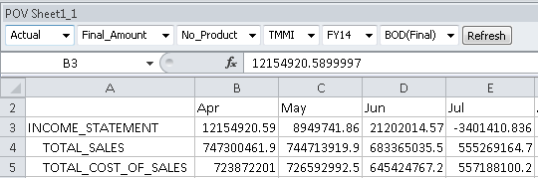

1. In the Planning tab in the Excel ribbon, click on the *Drill-through* button



1. Clicking the *Drill-through* button opens the menu to select the drill through method



1. Click *Drill to IE* to execute the drill and view the data in a web page



1. Click *Drill to Excel* to execute the drill and view the data directly in Excel



# Drilling in Reports



## Overview

Drill through is not supported natively in reports; however, the user has the option to open a report in *Query Ready Mode* which simplifies the process of rebuilding the report in SmartView and then drilling from SmartView.

The table below shows the reports in Hyperion that will be drillable when the report is opened in SmartView.



## Opening Reports in Query Ready mode from SmartView

1. Select a report from the Reporting and Analysis connection. Choose *Query-Ready* in the *Import Document As* drop down mean and click *Finish*.

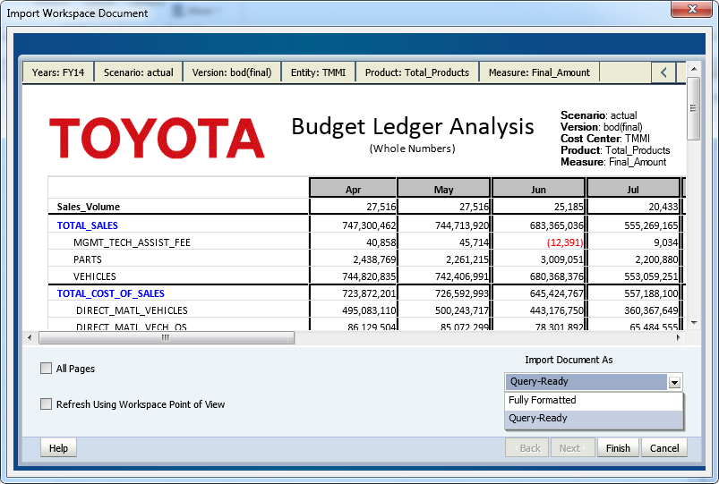

1. The report will open as an unformatted spreadsheet. From this view, change the connection from *Reporting and Analysis Framework* to *Oracle Hyperion Planning, Fusion Edition*.

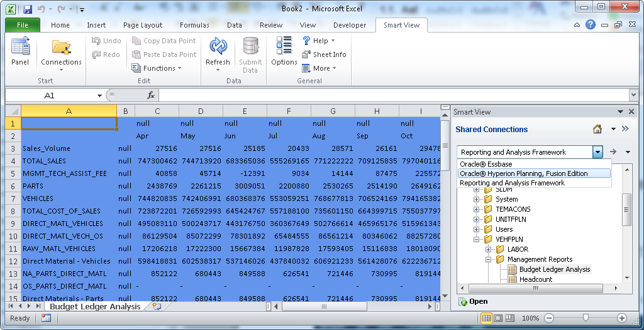

1. Double click the PL cube in the application that you are working in and then click *Ad hoc analysis*

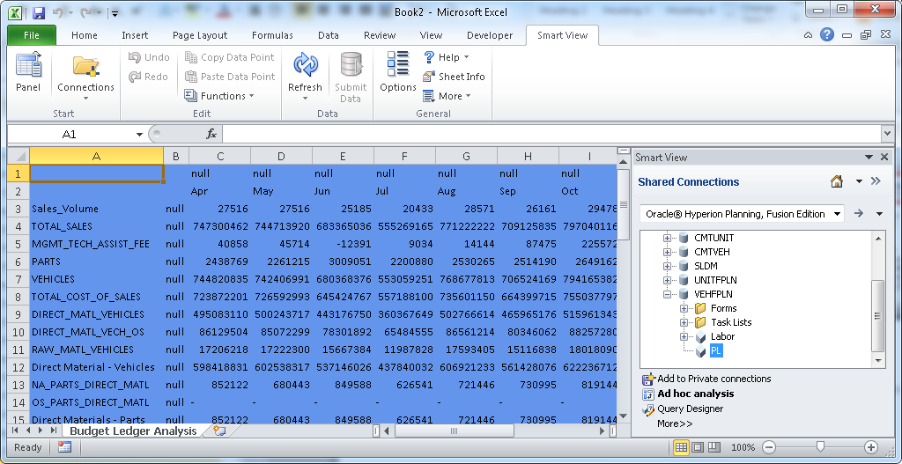

1. Reselect your POV and click *Refresh*

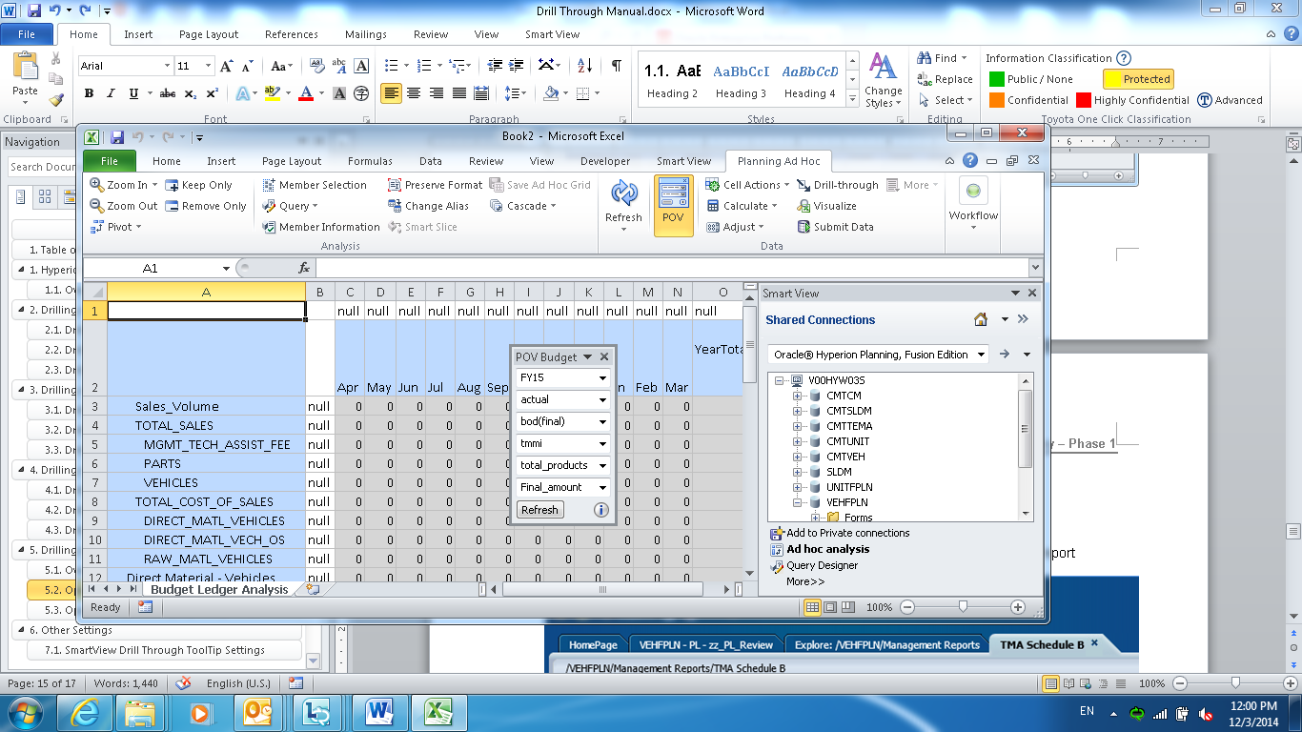

1. The report should now be drillable as indicated by the green outlined cells in SmartView.

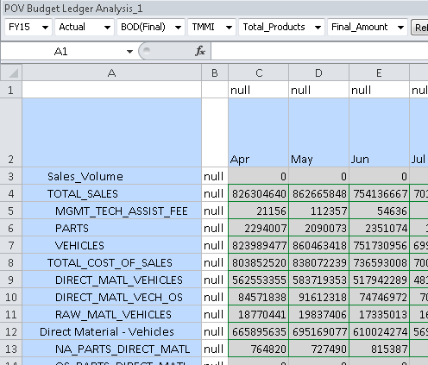

## Opening Reports in Query Ready Mode from the Web

1. Select *Export In Query Ready Mode* in the bottom right corner of the report

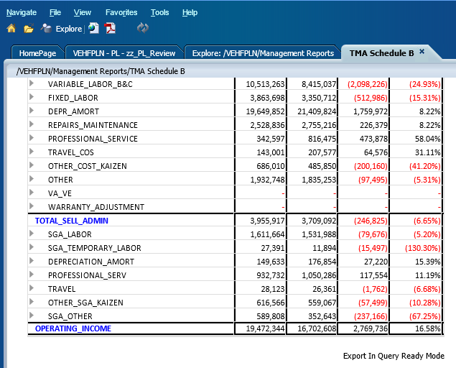

1. The report will open as an unformatted spreadsheet. From this view, connect to *Oracle Hyperion Planning, Fusion Edition* in the SmartView ribbon.



1. Double click the PL cube in the application that you are working in and then click *Ad hoc analysis*



1. Reselect your POV and click *Refresh*



1. The report should now be drillable as indicated by the green outlined cells in SmartView.



# Other Settings



## SmartView Drill Through ToolTip Settings

In SmartView, it is possible to show a list of the available dril through reports in a tooltip that displays when a cell is clicked. This behavior is demonstrated in the image below.

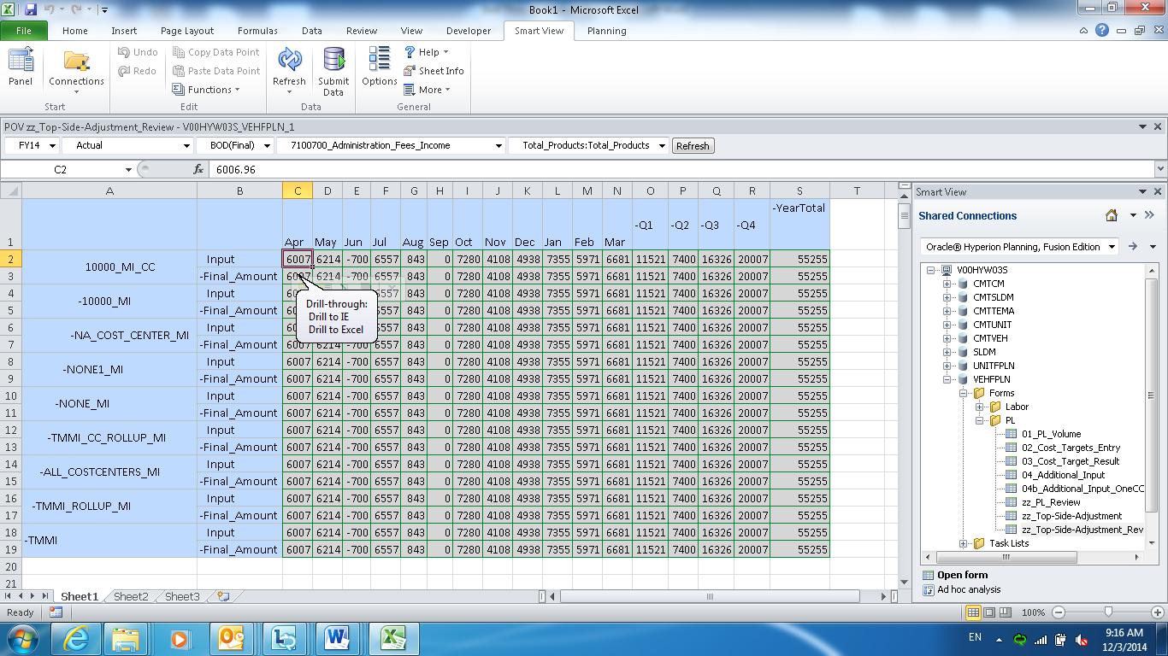

To turn off this feature, open the options menu by clicking the *Options* button in the SmartView ribbon.



Uncheck the *Display Drill Through Report ToolTips* option and click *OK*.

